**MESD LMS Documentation – Audit trails**

To facilitate with viewing audit trails of user logs.

**Background**

This module handles requests directly from Site administrators to view audit trails.

**Usage**

**Checking logs**

1. Log in as a Site admin or Super Admin.
2. Go to your *‘Site administration’* then *‘Reports’*.
3. Click on *‘Extended log search’*.

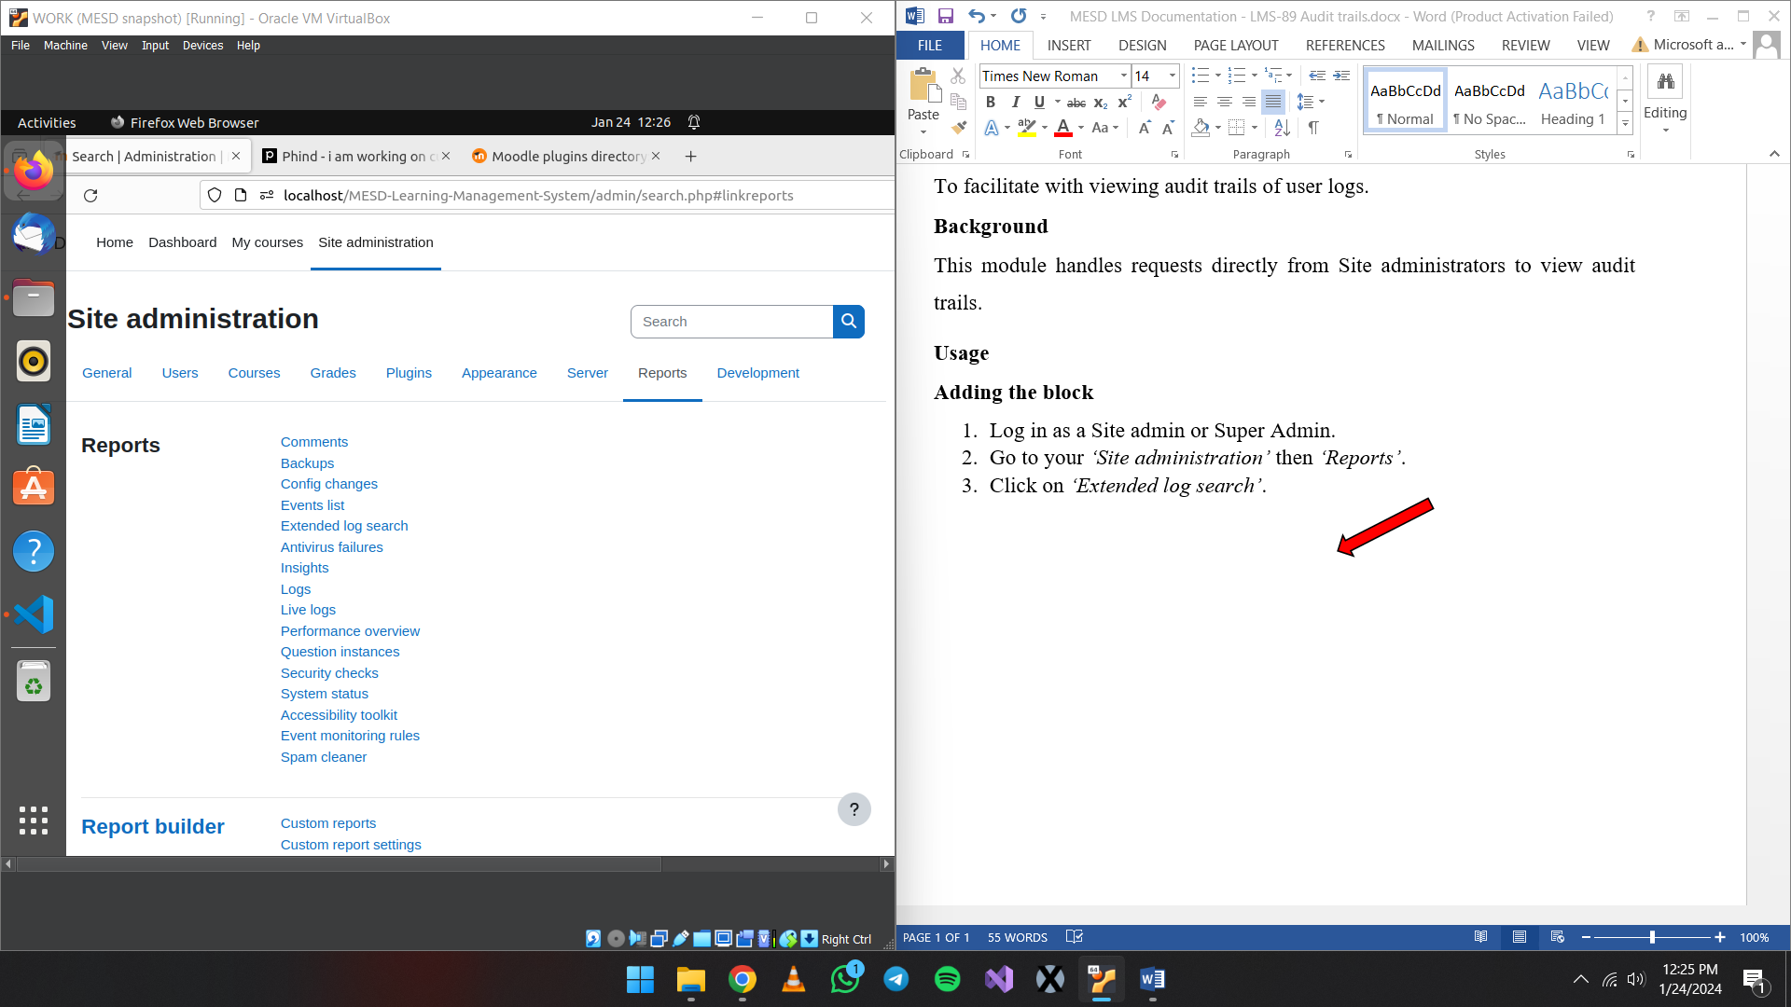

1. From here you can filter out by dates, users etc. If you just want to view every log just leave everything empty and click on *‘Show events’*.

1. Scroll down to view the log search results. Results show a table that has Time, User names, affected user, event context, component, event name, description, origin and IP address.

